Dear Sprocket Central Pty Ltd, I am writing to bring to your attention the identified data quality issues and strategies to mitigate these issues that have been found in our analysis. The following sheets have been evaluated for completeness, relevancy, consistency, and accuracy:

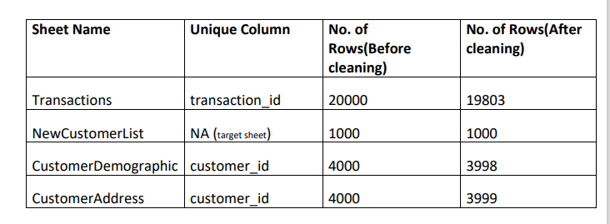

**Transactionssheet**: online_order, brand, product_line, product_class, product_size, standard cost, product first sold date contain null values.

**NewCustomerList**: DOB, job title, job industry contain null values. Gender = "U" (unknown) has been replaced with Unspecified.

**CustomerDemographic**: DOB, job title, job industry contain null values. deceased_indicator = "Y" (deceased) have been deleted. Default column has been deleted as it is not decodable and Gender = "U" (unknown) has been replaced with Unspecified.

**CustomerAddress:** State = "New South Wales" and "Victoria" have been changed to "NSW" and "VIC", respectively.

To mitigate these issues, the Data Handling team can try to tally the old data or relevant records to fill some null values, check the record of "U" in gender to find out the correct values, check the latest values used for fields so as to keep up to date database, and change data type from number to date for product first sold date column.

Maintaining high data quality is essential for effective decision making and business operations. We hope that these strategies will help improve the quality of our data.

Thank you for your attention to this matter.

Sincerely,

E.Durga.

Insight:   
By embracing these strategies, Sprocket Central Pty Ltd can secure precise and relevant data, ultimately enhancing their business operations. Routine checks and audits serve as proactive safeguards against future data quality challenges.